Final Report: -

Course Code: CSE326

Section: K22SG Group:2

Project Made By: -

1. Rahul Bhat: 63 (12208854)

Contribution: HTML Structure and CSS and JavaScript Codes and Final Report.

1. Arindam Maji: 62 (12208405)

Contribution: JavaScript Code and CSS Codes.

1. Soubhik Samanta: 61(12208397)

Contribution: JavaScript Code and CSS Codes.

A Restaurant Website

Abstract: In the recent years preceding the COVID-19 Outbreak, we saw a rise in the number of food deliveries taking place and now after the calming down of the spreading of the Virus we see a steady increase of the number of food deliveries taking place due to the convenience of food being delivered to our doorsteps. Hence, knowing the importance of a being able to see the Menu of a Restaurant we have created a website for a being able to see the Menu of a Restaurant called the ‘The Paneer Pot’ where a customer can call the Restaurant’s Contact No. provided on the website and order their specialities by browsing their Menu.

Introduction: -

**Picturize this.**  
You’re looking for a restaurant to go with your friends. Like every other technology-friendly person, you turn to the Internet because you know that every random business these days has a strong online presence. But to your dismay, you discover that you can’t find your favourite restaurant’s website because they’ve missed out on the opportunity to build their web existence.

A restaurant in today’s world must absolutely have a website because that’s not just the ongoing trend but also one of the most effective and economical forms of advertising and popularizing one’s restaurant. It won’t just make one’s eatery stand out but also enhances its business prospects.

1. A restaurant’s presence on the Internet is a chance at attaining marketing exposure at a humungous level. Thus, a spot on the World Wide Web i.e., restaurant websites are the most essential thing.
2. Restaurant websites can help by sharing a lot more information with customers than they would get to know from other sources. They help in finding maps, offers and discounts as well as special days.
3. Through restaurant websites, customers can have a share in their part of the world and thus let the restaurant create an experience for them.
4. The best part is that a lot of information and details can be printed on restaurant websites without any expenditure on printing or any kind of additional costs. Everything starting from menus to brochures to ads can be posted on the Internet and they’ll go viral in minutes. Moreover, more stuff can also be updated on the websites which’ll entertain the viewers.
5. Restaurant websites can also help in making things easy for customers by the new system of providing automated reservations. The website can also take care of planning parties, banquets and get-togethers and human resources can be aptly utilized in assisting in other work. Also, online ordering systems present in those websites can aid consumers by lessening their work and helping them pick up food or dropping off food at their place with a single click. Online ordering systems boost sales like nothing.
6. Restaurant websites are a great way to advertise because they’re available at reasonable rates can reach a wider audience. Ads posted in websites can be much cheaper than advertisements on billboards, magazines, kiosks, etc because the space is unlimited and they stay there for a longer duration of time.

Importance of a Website for Restaurants: -

* When customers check out restaurant websites to look for food, what attracts them most is the visual content of the website. It impacts their decision of coming in and dining or ordering food from that place. Tasteful images of the restaurant’s interior and exterior, delectable, etc to lure foodies.
* Including web-based menus instead of PDFs in restaurant websites makes it easy for customers to navigate through the website. Also including contact information, location and open/close hours makes it very convenient.
* Marrying of social media with websites of restaurants can help a great deal because Afterall, restaurants are meant to be social businesses.

Ordering IN: The rapid evolution of Food Delivery:

**How the world eats**is changing dramatically. A little under two decades ago, restaurant-quality meal delivery was still largely limited to foods such as pizza and Chinese. Nowadays, food delivery has become a global market worth more than $150 billion, having more than tripled since 2017.

Before the pandemic put thousands of establishments out of business, the US restaurant industry was growing 3 to 4 percent per year. Delivery sales were increasing at roughly twice that pace (7 to 8 percent). While population growth was a factor, the bulk of the increase came at the expense of the grocery sector, with millennials and Gen Z’ers preferring the convenience of prepared meals. This trend toward convenience has grown more pronounced during the pandemic. Between March and May 2020, when lockdowns in Europe and the United States were the most severe, the food-delivery market spiked. Significantly, it has maintained that trajectory, continuing to grow throughout 2020 and into 2021.

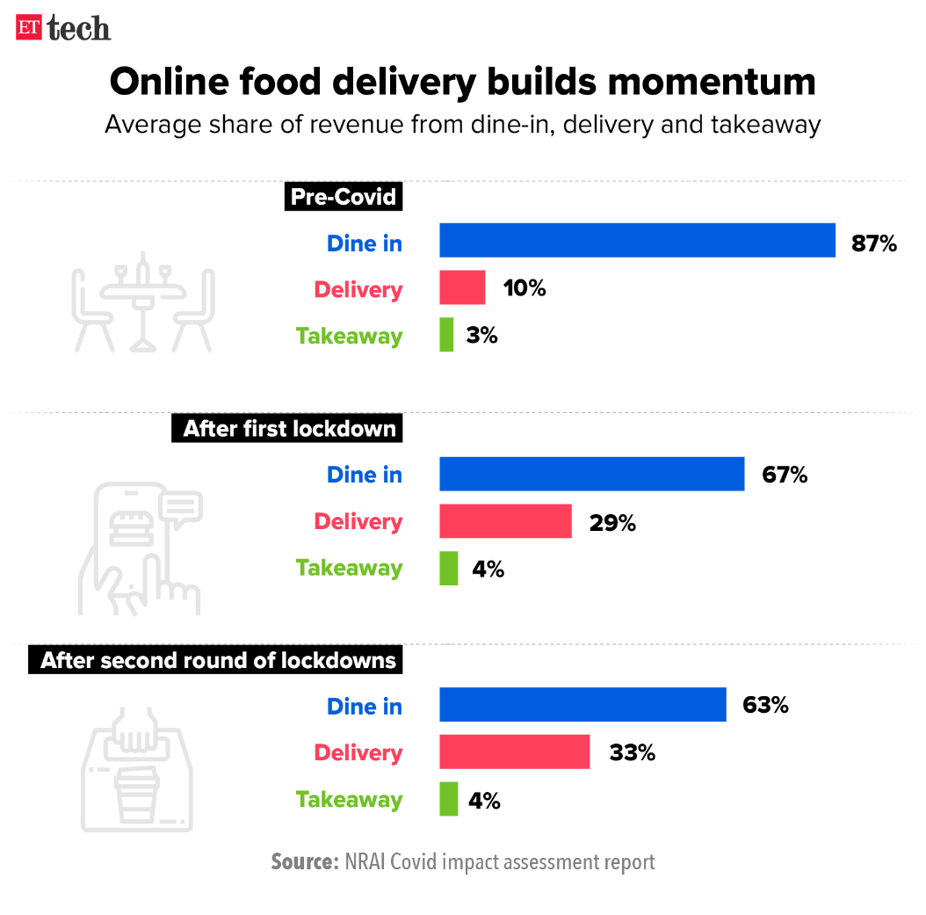

This Picture above tells us all about the story of Food Delivery in India, pre-COVID-19 and post-COVID-19.

As we can see the number of food deliveries as compared to previous years has significantly increased as compared to the decline in dine-ins over the years.

Related Works: -

Online food delivery service providers supply cooked meals and food items that are ordered online, mainly through mobile apps, for direct consumption. Food ordered through delivery providers are delivered to customers either by a restaurant-run delivery team (for example, Domino’s), or by a platform-run delivery team (for example, Zomato). The number of online food apps is rapidly increasing. These apps allow people to order and pick up food parcels and have them delivered to their homes.

## Market insights:

The online food delivery market in India was valued at INR 410.97 Bn in 2021. The market is expected to reach INR 1,845.76 Bn by the end of 2027, expanding at a CAGR of 30.00% during the 2022-2027 forecast period. Rapid digitalization and acceptance of online food delivery services among consumers across tier I and tier II cities are propelling the growth of the market.  
  
Increased adoption of the internet and smartphones, rise in the number of working families, especially the growing participation of women in the workforce, and rapid lifestyle changes drives the market.

## Key growth drivers of the market:

The growing smartphone user base and increasing adoption of the internet are driving the demand for app-based online food ordering in India. The simultaneous growth in acceptance and penetration of online food delivery mobile apps in tier I and tier II cities across India is leading to the growth of the market. Several online aggregators have tied up with restaurants to offer combo packages and one-serve meals to attract customers. Food delivery platforms have introduced subscriptions for loyal customers to do away with delivery charges imposed on every meal.

## Key deterrent to the growth of the market:

Penetrating beyond tier II cities is a challenge because the online food delivery market in India is dominated by unorganized players. The rise of fake food shops on food delivery platforms has created inconveniences to both customers and food delivery executives. Also, various food platforms charge high prices for delivering food to customers, especially during peak hours.

## COVID-19 impact analysis:

The nationwide lockdowns due to the COVID-19 pandemic initially caused some disruptions in the growth of the online food delivery market. However, it has positively impacted the market fulfilling people’s urge to eat outside while still complying with social distancing norms. The surge in online food orders recorded from Q3 2020 subsided during the second wave in April 2021 but has now returned to pre-COVID-19 levels.

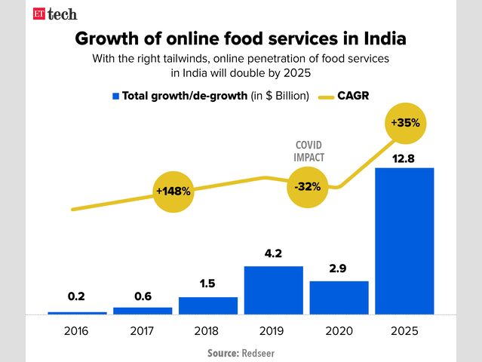

Novelty of the Proposed Work:

As we have seen the increase in the number of online food services in the last few years in the World as well as in India, we have come up with a website for our upcoming Restaurants in Pune because nowadays it is very crucial for a Restaurant to have an online website for its success as well as the need to maintain its success. Our website includes a Navigation Bar, which helps the user navigate conveniently through the website and it also contains the Contact Details for the Restaurant so that customers can get in contact with the Restaurant to order some delicious food. The website also contains information about the special offers and deals available at the Restaurant and also has a form which the user can fill to provide feedback to the Restaurant staff which is always very important from a Restaurant’s point of view. The website also contains a Login Page for the regular customers as well as new customers to login and experience the website.

Proposed Model: -

Our website mainly is made using HTML5 and CSS as well as validation of Forms using JavaScript. To create our website, we first thought of a Model by drawing out what all we wanted in our website and then started working on the basic structure consisting of Home, About, Menu, Deals, Gallery, Health Tips and Contact Us Pages as well as a Login option which would allow the customers to login to the page using a username and corresponding password. We also thought of a navigation bar for the user to be able to browse through the website easily so that the website would be convenient to interact with. We also made use of the ‘section’ tag to be able to separate the content out easily.

We also made use of CSS to beautify our website as well as style it properly and make it look attractive.

Using JavaScript, we were able to validate the forms that were going to be filled by the users which would pop up alerts to the users if the users made some obvious mistakes while filling the forms. We did not make use of any Backend so we had to make sure to Validate the login and contact us sections so that the users would not make errors while providing feedback to the restaurant staff as well as while trying to login.

The navigation bar above was made by using the ‘<ul>’ tag or the unordered list tag and nesting a ‘a’/anchor tag in it to the required sections and on the right-hand side of the navigation bar we also provided the contact details as well serving hours of the Restaurant so that the users could order Food to their doorstep. It also contains the logo of the Restaurant.

The most useful part of the navigation bar is that it will always be fixed to the top of the page due to the ‘sticky’ value of the position property.

1. 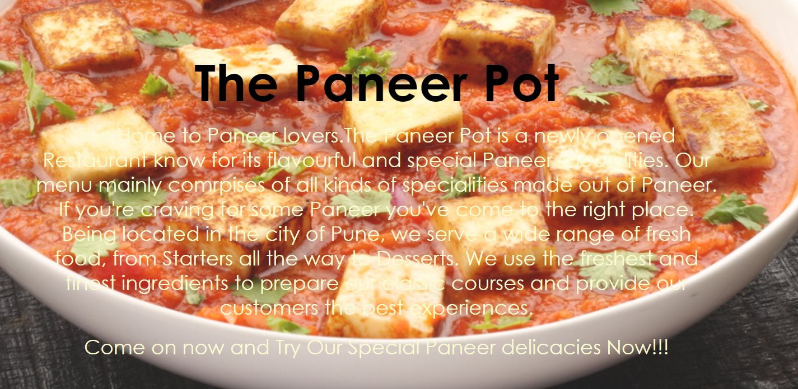Home

Then there is the Homepage which gives the customer the brief history of the Restaurant and the specialities of the place and how it came to its fame.

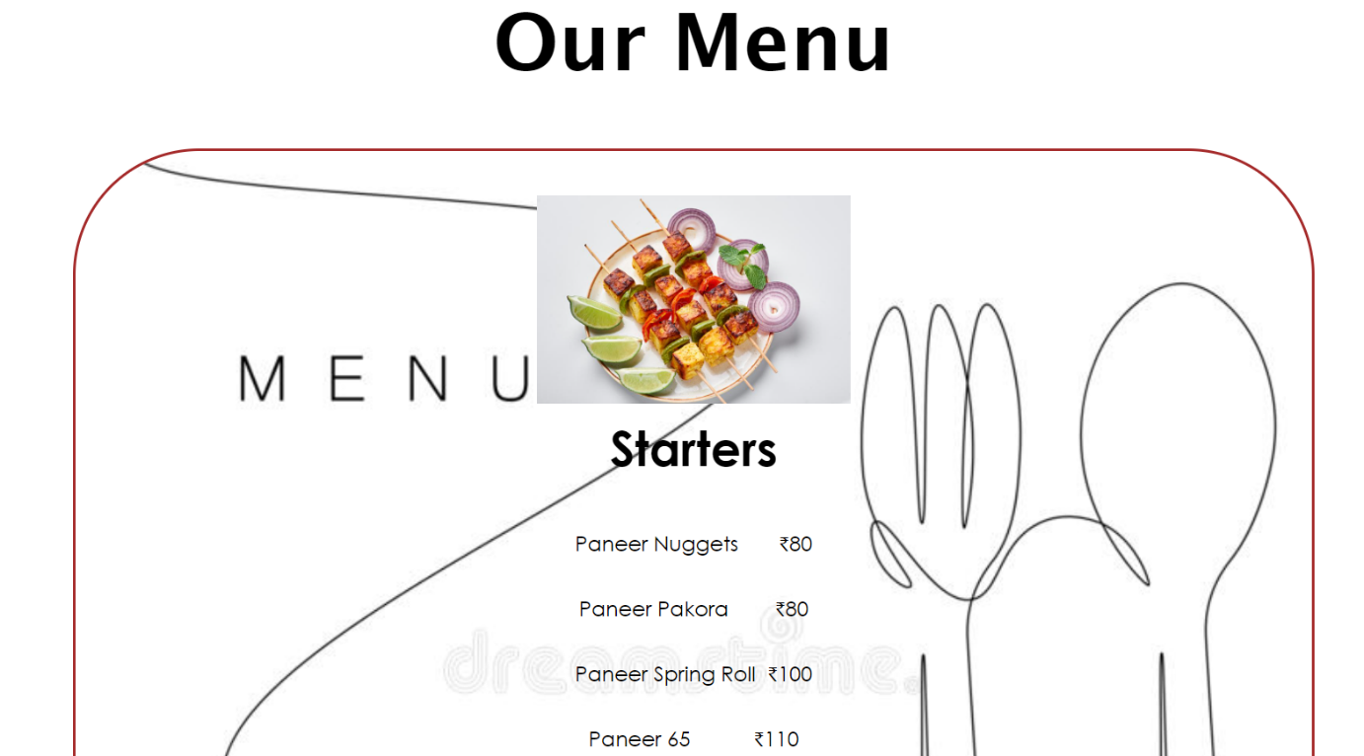

1. Menu

The next section is the Menu of the Restaurant which is the most important part of a Restaurant website. The menu is contained in a div container which also contains another div tag which contains another div container which contains the actual menu from starters to deserts.

1. Deals

The next section in our Website is the Deals/Special offers section where we display the deals of the Restaurant and the benefits of ordering online while at the comfort of sitting at your home.

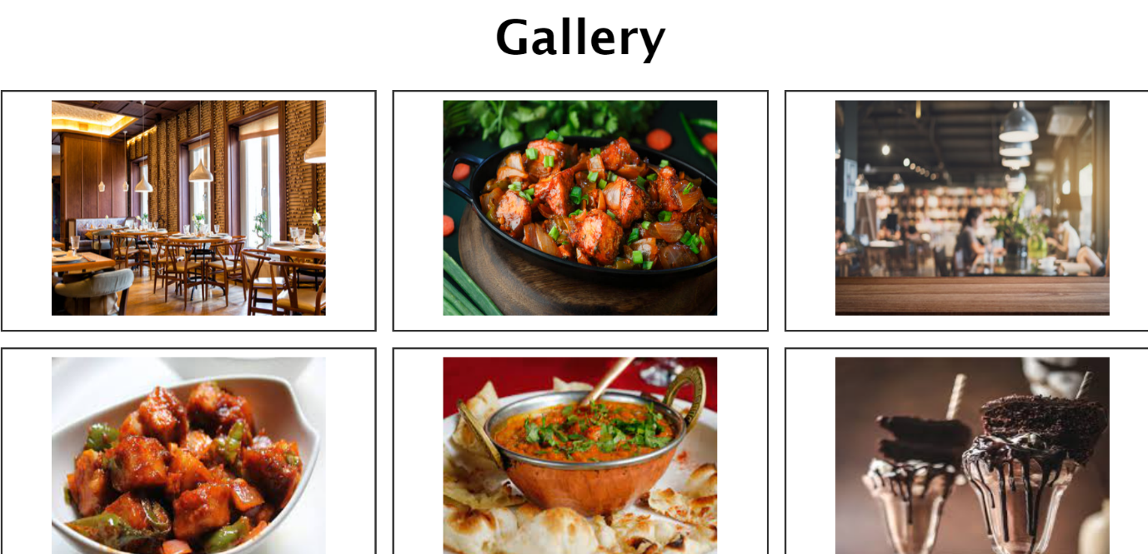

1. Gallery

The next page on the website shows the user the atmosphere at the Restaurant and the some of the pics of the specialities served at the Restaurant which can also be encouraging for the customers to visit the place sometime to dine in.

The Gallery section is made by the usage of ‘display: grid’ property and making use of grid-container and grid item concepts.

1. Contact Us

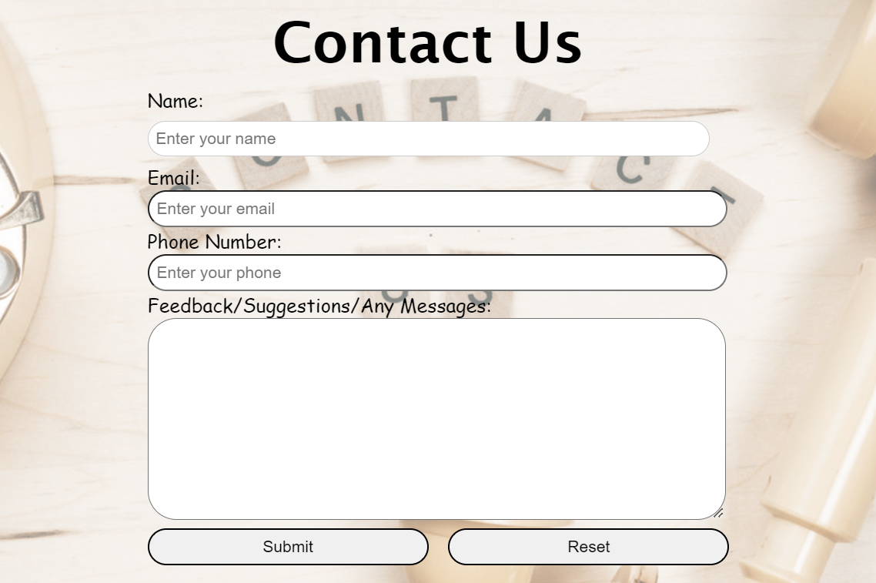And Last But not least, we have a Contact US Section which encourages users to provide us feedback/suggestions to improve our service towards them by using the form tag and which has also been validated and given alerts using JavaScript "onsubmit" concepts.

Roles of the Website: -

* To know the Working hours of Our Restaurant.
* The Location of Our Restaurant.
* What are our Restaurant’s specialities and what we serve.
* Special Offers and Deals.
* What kind of ambiance we offer through the Photos in our Gallery.
* To know if Customers can place online orders for delivery.

Future work: -

This Project has a lot of scope to be further improved and to be made better and for example a way to Order food from the Menu through the website is a way to improve the websites convenience even further which would help in increasing the number of customers to the Restaurant by huge amounts. The only major drawback of this project is the fact that there is no actual way for a user to order food from the website itself which can make it a bit inconvenient to use but nevertheless is another thing that can be worked on to make the website even further user-friendly in the future.

Conclusion: -

The conclusion of our Project is that a website for a Restaurant is very important and necessary because it helps promote the Restaurant and also helps in people knowing about the place as almost everyone nowadays surfs through the Internet for searching for places to eat as well as new places to order food from and a smooth and convenient website is the best way to get to know about a new and upcoming Restaurant.

References: -

* <https://www.restaurant-website-builder.com/advantages-of-having-a-website-for-a-restaurant>
* <https://www.w3schools.com/html/default.asp>
* <https://www.restolabs.com/blog/importance-restaurant-website>
* <https://economictimes.indiatimes.com/tech/tech-bytes/online-food-delivery-picks-up-again-as-third-wave-bites/articleshow/88818802.cms>
* https://www.researchandmarkets.com/reports/5690660/online-food-delivery-market-in-india-2022-2027